FitTrack

Logan Weigel

6-10-24 | Minsky Cohort

# Application Overview

# The Workout and Calorie Tracking App is a comprehensive tool designed to help users manage their fitness routines, track their dietary intake, and achieve their health goals. The app combines workout logging and calorie counting features with an intuitive interface, making it accessible for beginners and advanced users alike.

# Application Features

## 1.1 Home (Exercise Library/Search)

All users have access to the library/basic search includes ‘widgets’ to workout tracker/calorie tracker that will be locked until signed in. Users can search exercise db via search box or view a list of exercises by muscle group by selecting the image of the group.

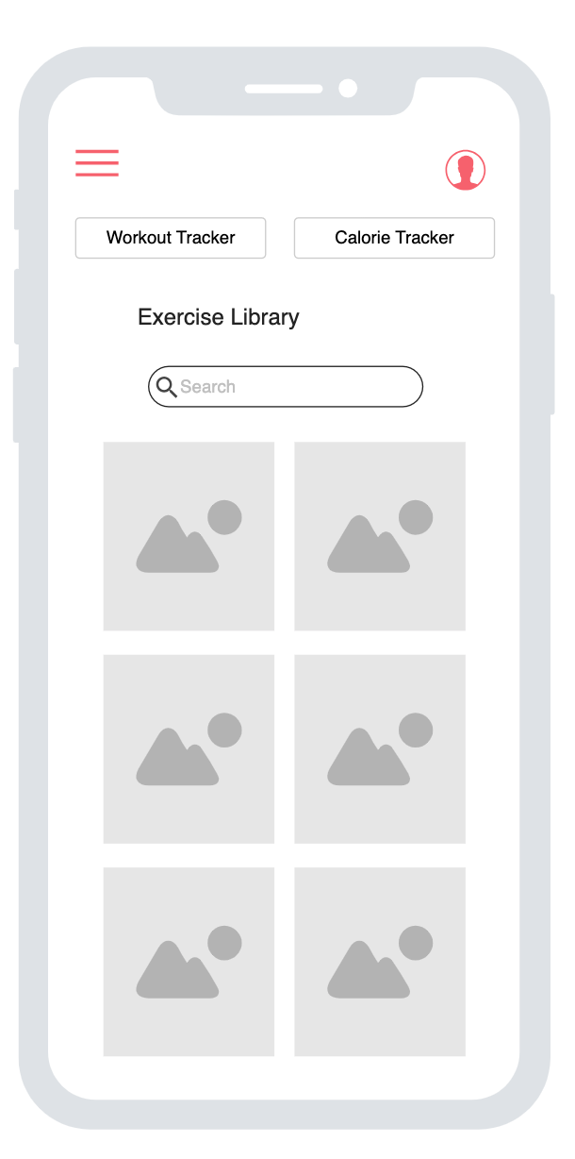

## 

## 1.2 Log-in/Register

Registered users will be able to log in to the application. The Log-in page will contain a link to the Registration page (no wireframe included). Registration will contain text inputs for username and password. The Registration page will also contain a button that navigates the user back to the Log-in screen and a button that will submit the form. After successful form submission, ( the user will automatically be logged in with the new account and sent back to the home screen.

Forgot password will not be included in this project.

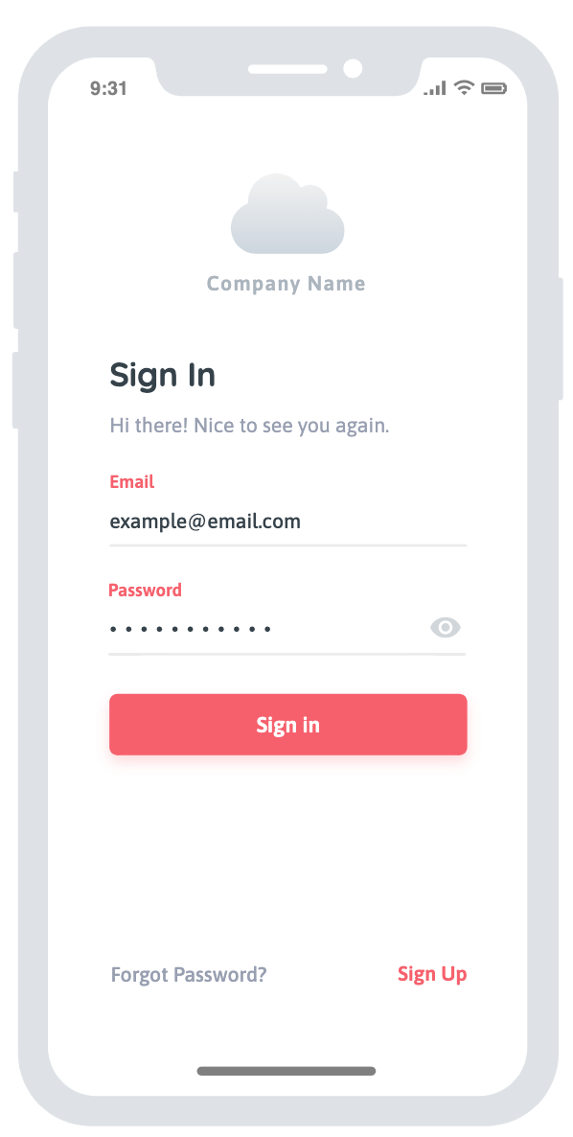 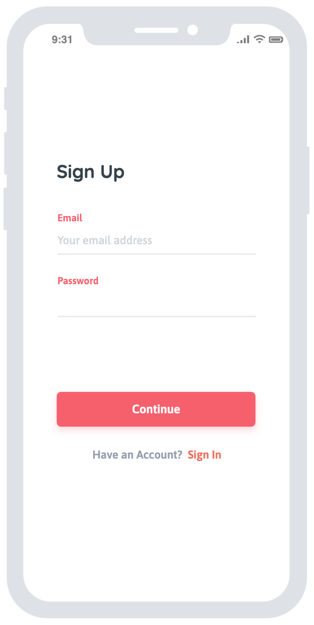

## 1.3 Workout Tracker

## Users will have the ability to add exercises to their log either on the log from the library. The Add Exercise button will display a modal to search exercises/enter initial data that is sent to the database. Each entry will be editable via edit button and have the option to be removed. Page will include a button to navigate back to the home screen. Add Exercise > Search > Enter exercise info

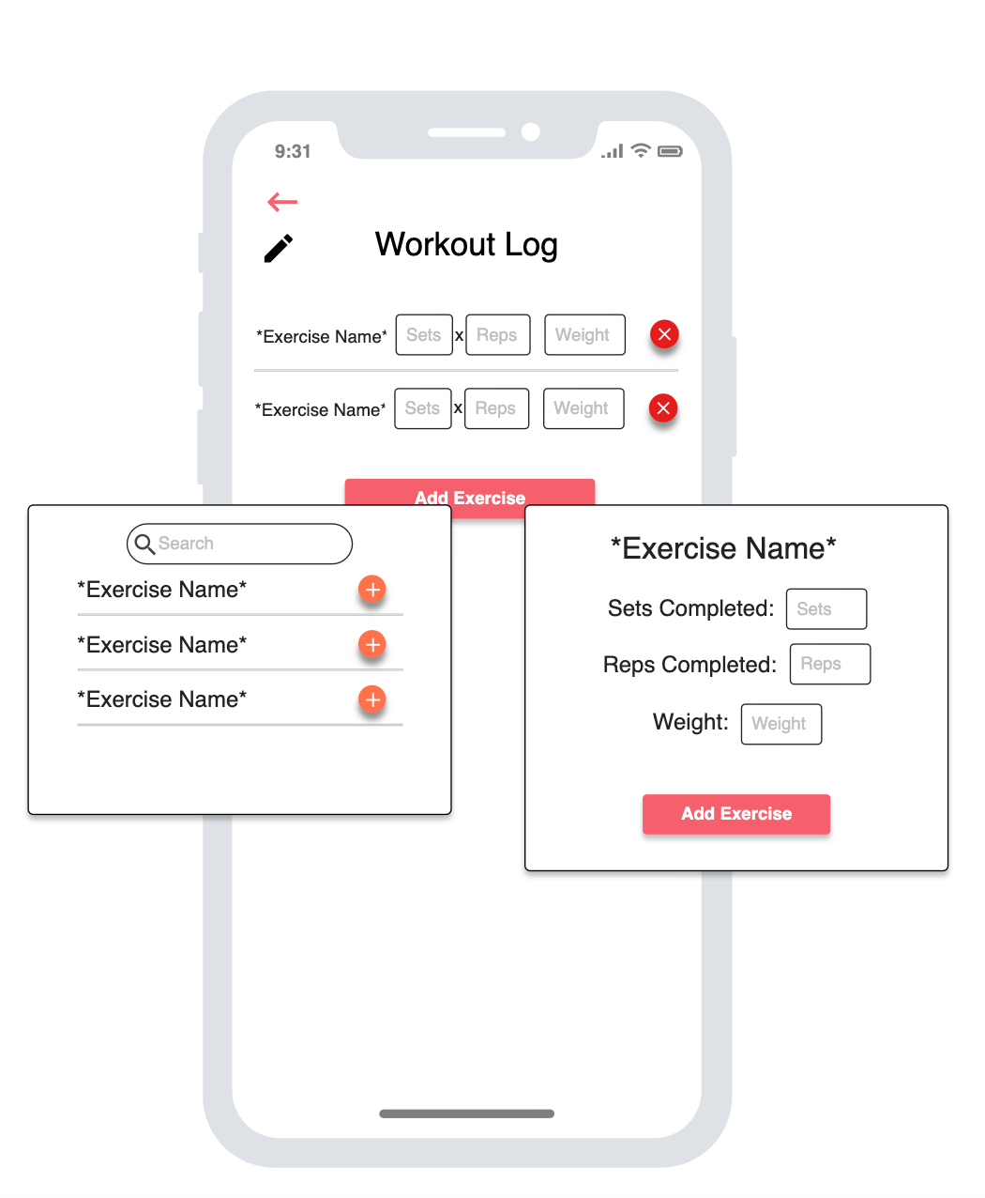

## 1.4 Calorie Tracker

Users will have the ability to add food/meal info (calories, macros) to the tracker. Any meal/food added will update the progress bar towards the daily calorie goal (calculated via bmr by info provided by the user). Entries will be deletable.

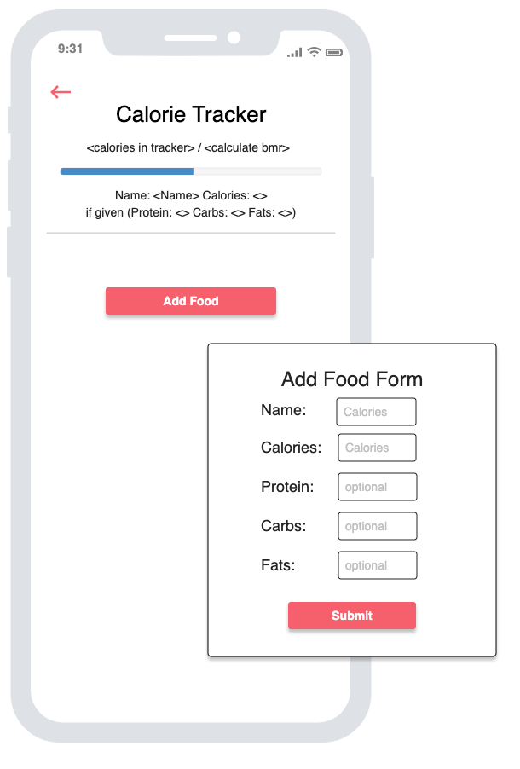

# 

# 

# Project Milestones and Schedule

| **Milestone (Should match a Feature from Above)** | **Hours Est.** | **Due Date** | **Base or Stretch** |
| --- | --- | --- | --- |
| Build database | 8 | 6/18 | Base |
| exercise library/search page and routes | 3-4 | 6/19 | Base |
| Sign in / Register page and routes | 3-4 | 6/21 | Base |
| Build out workout log w/ modals to add data and routes | 3-4 | 6/25 | Base |
| Build out calorie tracker page w/ modals to add data and routes | 3-4 | 6/26 | Base |
| Style, style, style | 12 | 6/28 | Base |
| Add Exercise Form (Admins) | 3-4 |  | stretch |
| Build out search to display previous dates logged workout/calories | 3-4 |  | stretch |
| Implement (chatGPT api/google api) on calorie tracker for users to search calories directly from app |  |  | stretch |

# 

# Database Documentation

(List out all of your routes here. Include an ERD after the first draft of your scope is complete. <http://www.dbdesigner.net/>)

fit_track database structure:

* User
  + Username - required
  + Password - required
  + Admin - required
* User_info
  + User_id references user.id
  + Height - required
  + Weight - required
  + Age - required
  + Gender - required
  + Bmr - calculated by above info
* musclegroups
  + Name - required
* Workout_log
  + User_id references user.id
  + Musclegroup_id references musclegroup.id
  + date - required
* Exercise_muscles (join table)
  + Exercise_id references exercise.id
  + Muscle_id references musclegroups.id
* Workout_details
  + Workout_id references workout.id
  + Exercise_id references exercise.id
* Set_info
  + Detail_id int references workout_details
  + Set_number int
  + Reps
  + weight
* Exercises
  + Name - required
  + videoURL
* Steps
  + Exercise_id references exercises.id
  + Step_number
  + description
* Calorie_log
  + User_id references user.id
  + Date - required
* Cl_entry
  + Log_id int references calorie_log.id
  + Food_name - required
  + Calories - required
  + Protein
  + Carbs
  + Fat

# 

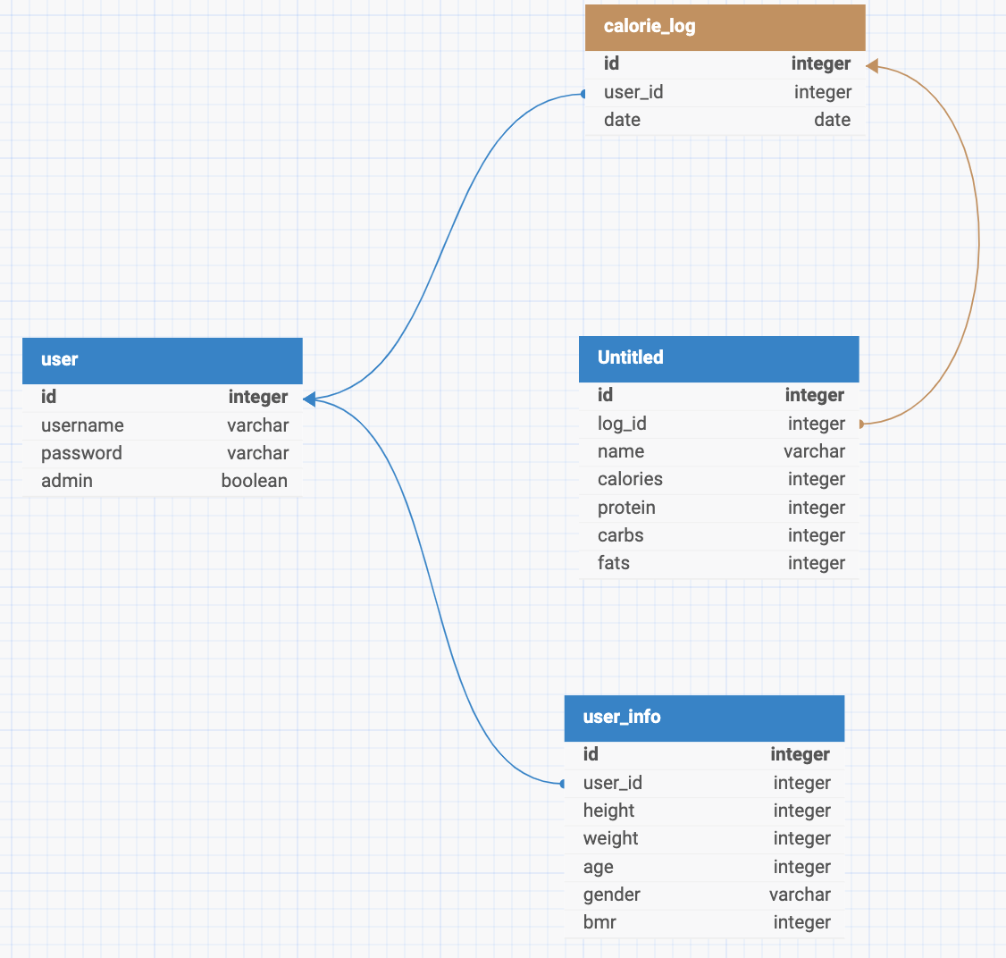

# Browsers

Application will fully support browsers listed below. All browsers or versions not listed below are considered out of scope.

| **Browser Name** | **Mobile or Desktop?** | **Version** |
| --- | --- | --- |
| Google Chrome | Mobile | 126 |

# Assumptions

While completing this estimate the following assumptions were made.

* Everything seems pretty straight forward and no major issues will appear.
* Users will primarily use on mobile devices

# Technologies

* Node
* Express
* React
* Postgresql
* Redux
* Passport.js
* NextUI
* Fly.io